TUI Congress – Cork 2017
Tours organised for Wednesday 19th April

The ‘TUI Congress TOURS’ stand will be taking bookings throughout the day on Tuesday and on Wednesday morning at TUI Congress. If you are interested in attending any of these tours (which will take place on the afternoon of Wednesday 19th April) please visit the stand as early as possible, to advise the stand holders of your interest, to ensure your place. Transportation to and from the Clayton Hotel Silver Springs is included.

TOUR 1- Charles Fort Headland Walk, Kinsale

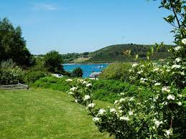 | 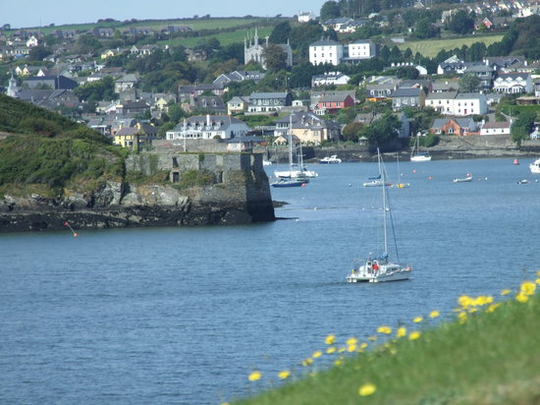

Join us for a beautiful walk along the costal headland of Charles Fort Headland

This walk will start at the historical Star Fort and goes out past the castle and along the bay overlooking Kinsale Harbour and St. James' Fort on the head of the other peninsula. It continues following the path along the coast to the boat yard and crosses over onto a beautiful vantage point looking back at the castle and Kinsale Town. This path is continued along the headland until the islands by Oysterhaven and the coast of West Cork become visible. This is an exceptionally beautiful place.

This walk is suitable for adults and children (not accessible for buggies).
Please ensure you are wearing suitable footwear and pack wetgear.
This walk will last approximately 2.5 hours.

Please note that this tour may be cancelled if weather conditions dictate.

TOUR 2 – Kinsale Harbour Cruise

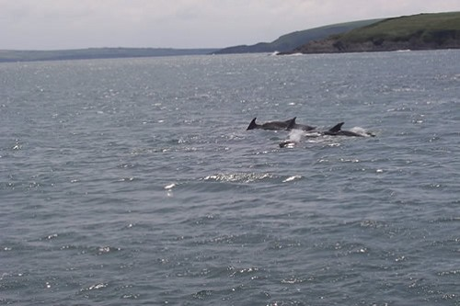 | 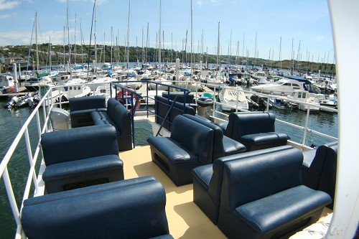

Come on board the 'Spirit of Kinsale' for a spectacular tour of Kinsale Harbour

The Kinsale Harbour Cruise will give you a very different view of Kinsale and its beautiful natural harbour. Our unique trip is an opportunity to view Kinsale town from the water.

This cruise will last approximately 1 hour which will give you some free time to explore what Kinsale Town has to offer.

For additional information please see: www.kinsaleharbourcruises.com

TOUR 3 – FOTA Wildlife Park

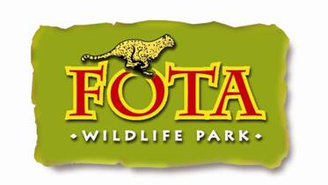 | 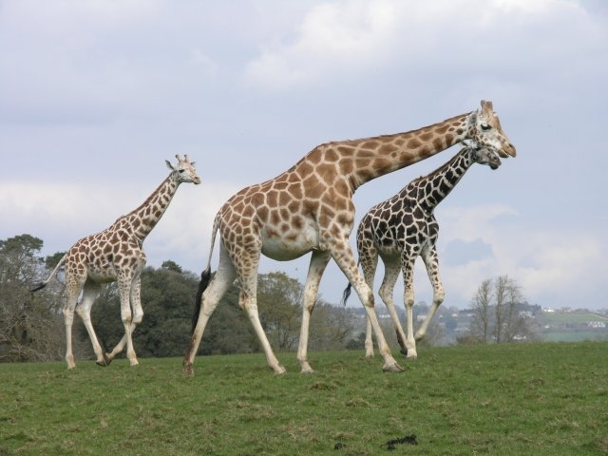

Join us on a two hour guided tour in the beautiful FOTA Wildlife Park

On this tour you’ll be guided through 100 acres of Wildlife Park with a qualified member of the team who will tell you about the many species of animals in the park and the park’s work towards conservation, education and research.

You can see a diverse range of animals from tigers and tapirs, lions and lemurs and some native wildlife too!

For additional information please see: www.fotawildlife.ie

The 2017 TUI Congress Golf Tournament
– FOTA ISLAND GOLF CLUB

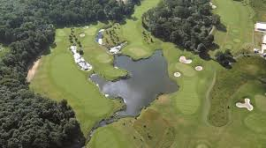

Welcome to a good walk unspoiled

The outstanding natural landscapes of Fota Island Golf Club offer a golfing experience that’s simply unmatched in Ireland, let alone Cork.

The golf club boasts three championship standard golf course configurations - the original Deerpark (Par 71), Belvelly (Par 72) and Barryscourt (Par 73). The championship Cork golf club hosted to the 2001, 2002 and 2014 Irish Open. In 2011 & 2012, the golf club also hosted the PGA Europro Audi Cork Irish Masters.

There is always healthy competition with the Congress golf tournament and various prizes will be awarded at break time on Thursday.

